Acceleration of Computational Screening of Separation of Xylene Isomers through Simplified Molecular Models and Advanced Monte Carlo Techniques

Zhao Li, Haoyuan Chen, Arun Gopalan, and Randall Q. Snurr*

Department of Chemical and Biological Engineering, Northwestern University, Evanston, Illinois 60208, United States

# Molecular simulation details

**Table S1**. Lennard-Jones parameters of three-site models for xylene isomers

|  |  |  |  |
| --- | --- | --- | --- |
| Atom Type | $$ϵ/k_{B}(K)$$ | $$σ (Å)$$ | $$q(e)$$ |
| Approximate Benzene (AB) | 440 .0 | 5.27 | 0.0 |
| Methyl Group (CH3-), OPLS model | 85.51 | 3.80 | 1.15 |
| Methyl Group (CH3-), TSX model | 85.51 | 3.80 | 0.0 |
| Methyl Group (CH3-), TraPPE | 98.0 | 3.75 | 0.0 |
| Approximate Ethane (AE) | 235.1 | 4.51 | 0.0 |
| C, OPLS model | 35.24 | 3.55 | -1.15 |
| H, OPLS model | 15.03 | 2.42 | 1.15 |
| Ac | 16.6 | 3.1 | 0.0 |
| Ag | 18.11 | 2.8 | 0.0 |
| Al | 254.09 | 4.01 | 0.0 |
| Am | 7.04 | 3.01 | 0.0 |
| Ar | 93.08 | 3.45 | 0.0 |
| As | 155.47 | 3.77 | 0.0 |
| At | 142.89 | 4.23 | 0.0 |
| Au | 19.62 | 2.93 | 0.0 |
| B | 90.57 | 3.64 | 0.0 |
| Ba | 183.15 | 3.3 | 0.0 |
| Be | 42.77 | 2.45 | 0.0 |
| Bi | 260.63 | 3.89 | 0.0 |
| Bk | 6.54 | 2.97 | 0.0 |
| Br | 126.29 | 3.73 | 0.0 |
| C | 52.83 | 3.43 | 0.0 |
| Ca | 119.75 | 3.03 | 0.0 |
| Cd | 114.72 | 2.54 | 0.0 |
| Ce | 6.54 | 3.17 | 0.0 |
| Cf | 6.54 | 2.95 | 0.0 |
| Cl | 114.21 | 3.52 | 0.0 |
| Cm | 6.54 | 2.96 | 0.0 |
| Co | 7.04 | 2.56 | 0.0 |
| Cr | 7.55 | 2.69 | 0.0 |
| Cu | 2.52 | 3.11 | 0.0 |
| Cs | 22.64 | 4.02 | 0.0 |
| Dy | 3.52 | 3.05 | 0.0 |
| Eu | 4.03 | 3.11 | 0.0 |
| Er | 3.52 | 3.02 | 0.0 |
| Es | 6.04 | 2.94 | 0.0 |
| F | 25.16 | 3 | 0.0 |
| Fe | 6.54 | 2.59 | 0.0 |
| Fm | 6.04 | 2.93 | 0.0 |
| Fr | 25.16 | 4.37 | 0.0 |
| Ga | 208.81 | 3.9 | 0.0 |
| Ge | 190.69 | 3.81 | 0.0 |
| Gd | 4.53 | 3 | 0.0 |
| H | 22.14 | 2.57 | 0.0 |
| He | 10.9 | 2.64 | 0.0 |
| Hf | 36.23 | 2.8 | 0.0 |
| Hg | 193.71 | 2.41 | 0.0 |
| Ho | 3.52 | 3.04 | 0.0 |
| I | 170.57 | 4.01 | 0.0 |
| In | 301.39 | 3.98 | 0.0 |
| Ir | 36.73 | 2.53 | 0.0 |
| K | 17.61 | 3.4 | 0.0 |
| Kr | 110.69 | 3.7 | 0.0 |
| La | 8.55 | 3.14 | 0.0 |
| Li | 12.58 | 2.18 | 0.0 |
| Lu | 20.63 | 3.24 | 0.0 |
| Lr | 5.53 | 2.88 | 0.0 |
| Md | 5.53 | 2.92 | 0.0 |
| Mg | 55.85 | 2.69 | 0.0 |
| Mn | 6.54 | 2.64 | 0.0 |
| Mo | 28.18 | 2.72 | 0.0 |
| N | 34.72 | 3.26 | 0.0 |
| Na | 15.09 | 2.66 | 0.0 |
| Ne | 21.13 | 2.66 | 0.0 |
| Nb | 29.69 | 2.82 | 0.0 |
| Nd | 5.03 | 3.18 | 0.0 |
| No | 5.53 | 2.89 | 0.0 |
| Ni | 7.55 | 2.52 | 0.0 |
| Np | 9.56 | 3.05 | 0.0 |
| O | 30.19 | 3.12 | 0.0 |
| Os | 18.62 | 2.78 | 0.0 |
| P | 153.46 | 3.69 | 0.0 |
| Pa | 11.07 | 3.05 | 0.0 |
| Pb | 333.59 | 3.83 | 0.0 |
| Pd | 24.15 | 2.58 | 0.0 |
| Pm | 4.53 | 3.16 | 0.0 |
| Po | 163.52 | 4.2 | 0.0 |
| Pr | 5.03 | 3.21 | 0.0 |
| Pt | 40.25 | 2.45 | 0.0 |
| Pu | 8.05 | 3.05 | 0.0 |
| Ra | 203.27 | 3.28 | 0.0 |
| Rb | 20.13 | 3.67 | 0.0 |
| Re | 33.21 | 2.63 | 0.0 |
| Rh | 26.67 | 2.61 | 0.0 |
| Rn | 124.78 | 4.25 | 0.0 |
| Ru | 28.18 | 2.64 | 0.0 |
| S | 137.86 | 3.59 | 0.0 |
| Sb | 225.91 | 3.94 | 0.0 |
| Sc | 9.56 | 2.94 | 0.0 |
| Se | 146.42 | 3.75 | 0.0 |
| Si | 202.27 | 3.83 | 0.0 |
| Sm | 4.03 | 3.14 | 0.0 |
| Sn | 285.28 | 3.91 | 0.0 |
| Sr | 118.24 | 3.24 | 0.0 |
| Ta | 40.75 | 2.82 | 0.0 |
| Tb | 3.52 | 3.07 | 0.0 |
| Tc | 24.15 | 2.67 | 0.0 |
| Te | 200.25 | 3.98 | 0.0 |
| Th | 13.08 | 3.03 | 0.0 |
| Ti | 8.55 | 2.83 | 0.0 |
| Tl | 342.14 | 3.87 | 0.0 |
| Tm | 3.02 | 3.01 | 0.0 |
| U | 11.07 | 3.02 | 0.0 |
| V | 8.05 | 2.8 | 0.0 |
| W | 33.71 | 2.73 | 0.0 |
| Xe | 167.04 | 3.92 | 0.0 |
| Y | 36.23 | 2.98 | 0.0 |
| Yb | 114.72 | 2.99 | 0.0 |
| Zn | 62.39 | 2.46 | 0.0 |
| Zr | 34.72 | 2.78 | 0.0 |
| O (MTW zeolite) | 48.16 | 3.03 | -0.652 |
| Si (MTW zeolite) | 156.00 | 3.80 | 1.305 |
| V (MIL-47) | 8.05 | 3.144 | 1.68 |
| C1 (MIL-47) | 47.856 | 3.473 | -0.15 |
| C2 (MIL-47) | 47.856 | 3.473 | 0.0 |
| C3 (MIL-47) | 47.856 | 3.473 | 0.56 |
| O1 (MIL-47) | 48.159 | 3.033 | -0.60 |
| O2 (MIL-47) | 48.159 | 3.033 | -0.52 |
| H (MIL-47) | 7.649 | 2.846 | 0.12 |

## Workflow of EB-CBMC

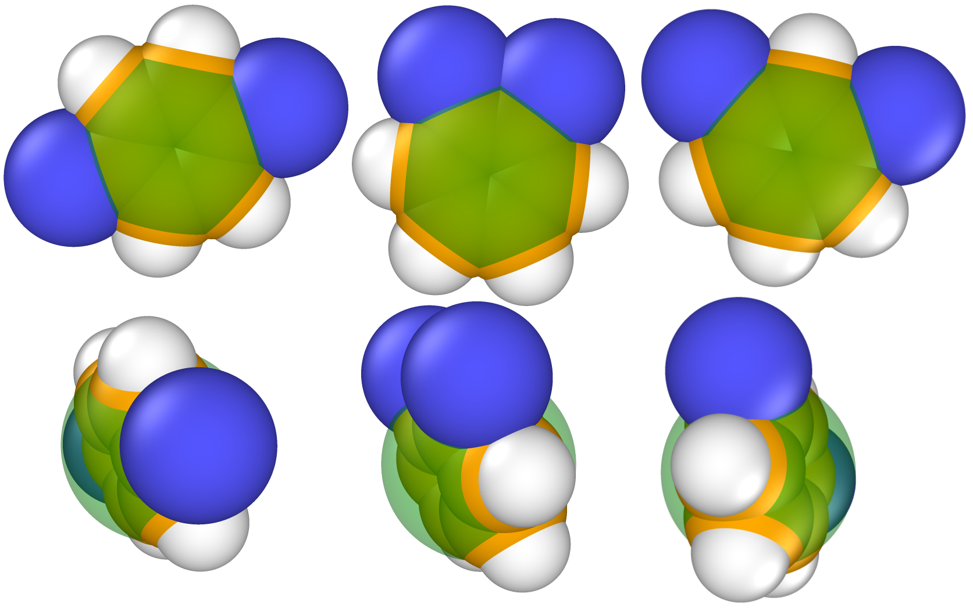

**Figure S1**. Modified molecular models for pX (left), oX (middle), and mX (right). White, yellow, blue, and green particles represent hydrogen, carbon, methyl, and fictional approximate benzene, respectively. The sizes of the particles are the Van der Waals radii (**Table S1**). The transparencies of the approximate benzene pseudo-atoms were higher is to represent their fictitious status. The AB atoms are only used for EBMC, not for energy calculations.

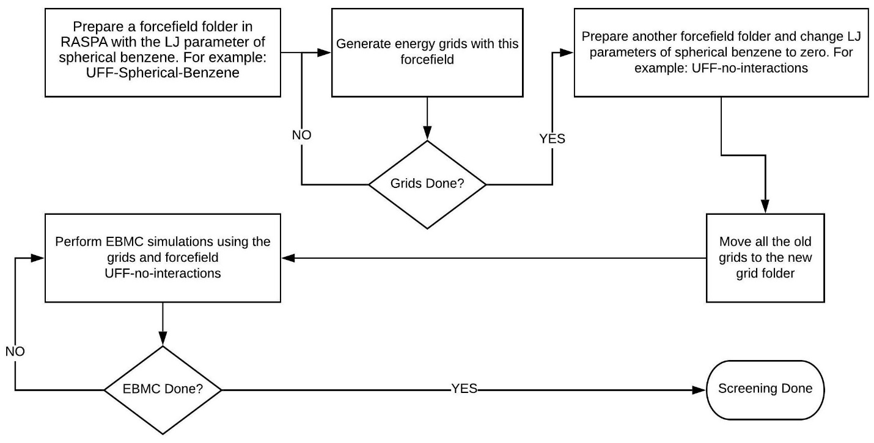

**Figure S2**. Flowchart of the screening process using EBMC simulations.

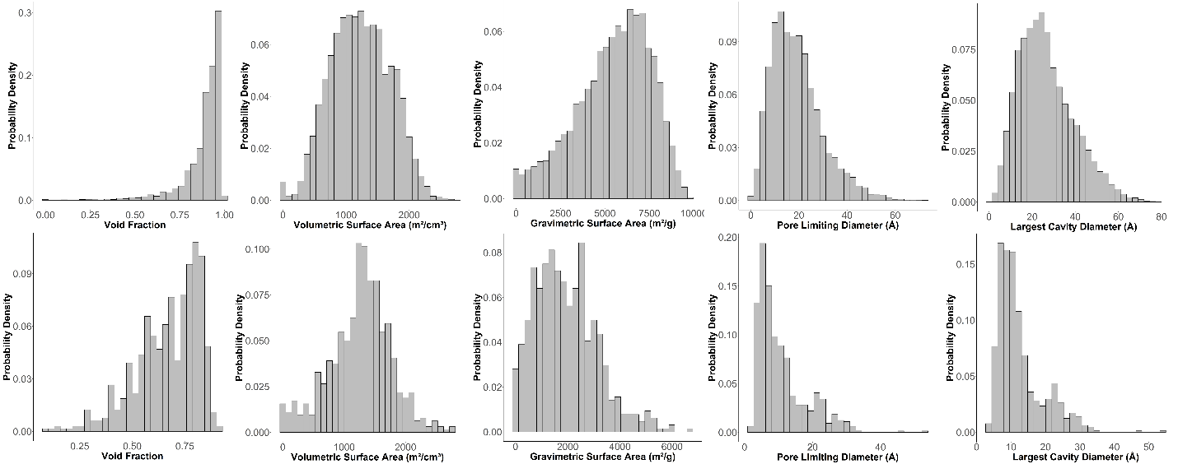

**Figure S3**. Histograms of void fraction, volumetric surface area in m2/cm3, gravitational surface area in m2/g, pore limiting diameter in Å, and largest cavity diameter in Å. First row: Full ToBaCCo 1.0 database. Second row: 640 selected MOFs. The probabilities on the y-axes are normalized to 1.

## Validation of algorithm

### Ethane isotherm in MOF MIL-47

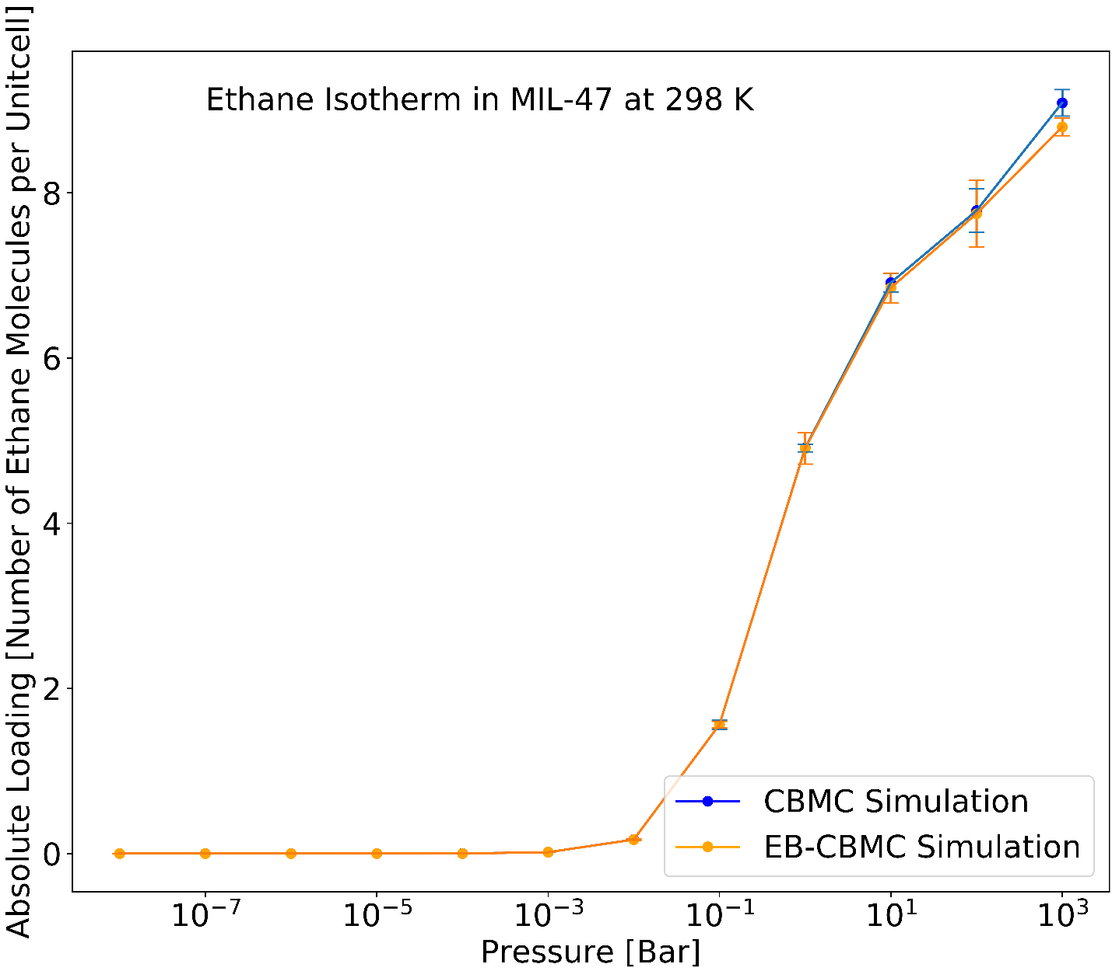

**Figure S4**. Ethane isotherms in MOF MIL-47 at 298 K using CBMC and EB-CBMC.

### Xylene Separation Isotherm in MIL-47

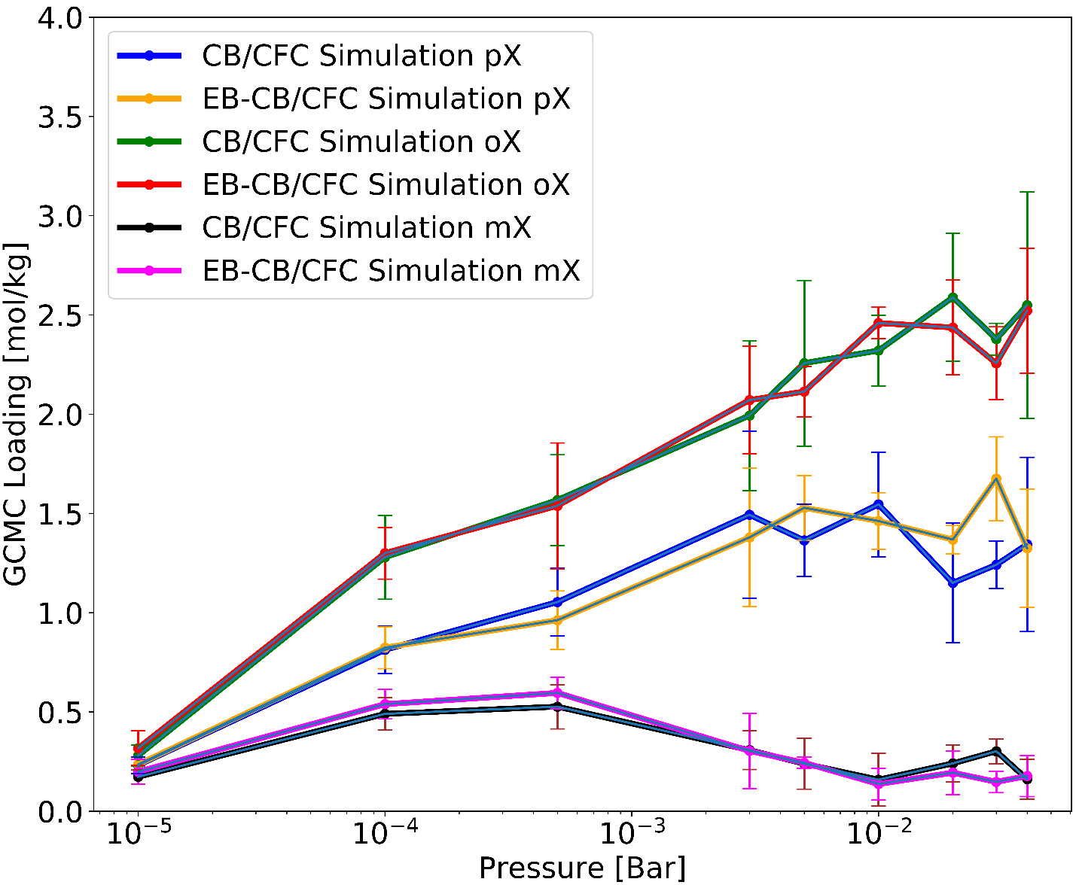

**Figure S5**. Mixture isotherm comparison between EB-CB/CFC and CB/CFC simulations in MIL-47 at 343 K.

# Xylene Mixture in Zeolite MTW

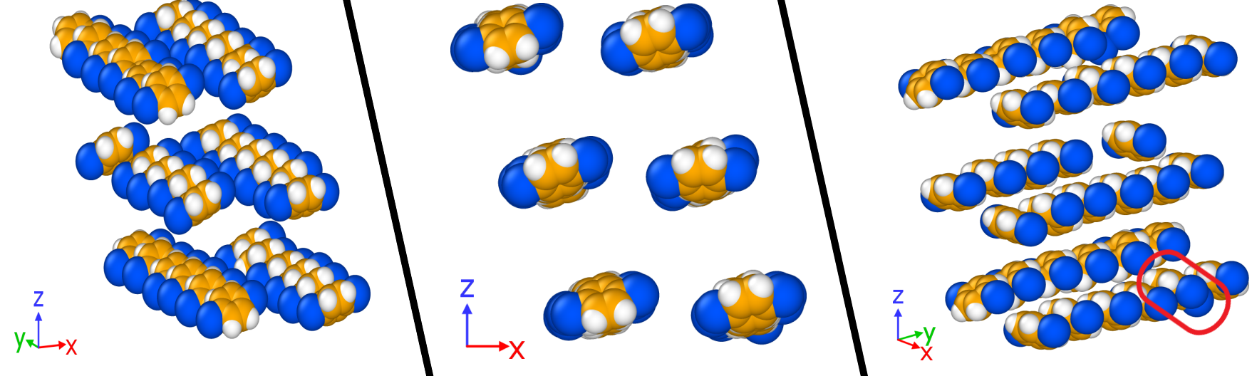

**Figure S6**. Snapshots of equimolar xylene mixture in MTW zeolite at 433 K and 103 Bar fugacity from 3 points of view. We highlighted the defecting oX molecule using a red circle.

# Zeolite JSW

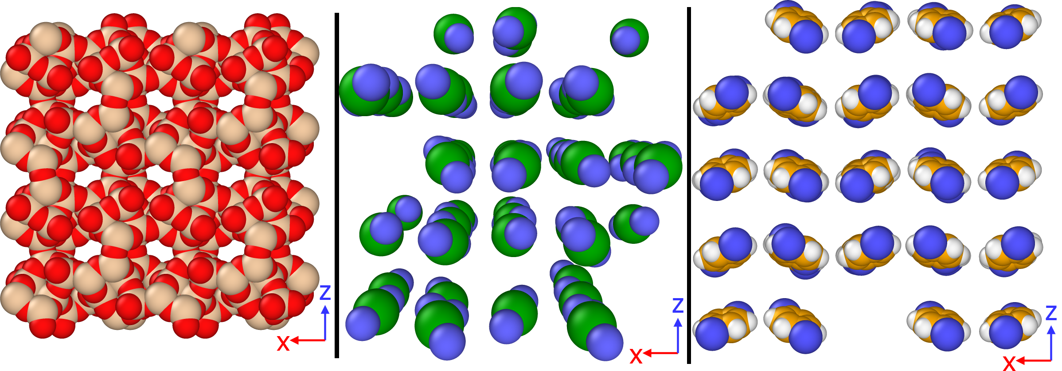

**Figure S7**. Snapshot of three-site xylene (middle) and full model xylene (right) in zeolite JSW in a mixture simulation.

# TSX pX in MTW Zeolite

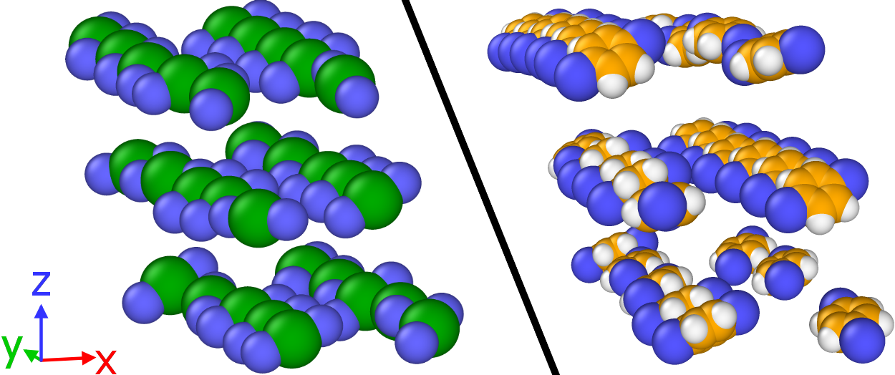

**Figure S8**. Left: TSX pX adsorption at 433 K and 103 Bar fugacity in MTW zeolite after 6 million cycles using CBMC. Right: Full model adsorption after 2 Million CBMC cycles.

# Comparison between selected structures

**Table S2**. Summary of highlighted MOFs for comparison between the three-site model and full model results. The colors are compatible with the highlights from **Figure 6**.

|  |  |  |  |  |  |  |
| --- | --- | --- | --- | --- | --- | --- |
| MOF | TSX pX [mol/kg] | TSX oX [mol/kg] | TSX mX [mol/kg] | Full Model pX [mol/kg] | Full Model oX [mol/kg] | Full Model mX [mol/kg] |
| #199 | 2.602 | 0.111 | 0.072 | 2.269 | 0.299 | 0.149 |
| #8995 | 0.792 | 0.115 | 0.113 | 1.016 | 0.043 | 0.022 |
| #2356 | 0.017 | 1.408 | 0.188 | 0.069 | 1.356 | 0.172 |
| #4866 | 0.783 | 1.922 | 0.576 | 0.729 | 1.974 | 0.460 |
| #119 | 2.366 | 0.552 | 1.143 | 0.853 | 1.309 | 2.016 |
| #325 | 0.261 | 0.065 | 1.065 | 0.190 | 0.226 | 0.924 |

**Table S3**. Textural properties of highlighted structures and outlying structures of the three-to-full workflow. The green ones represent the outliers (including 8995, which was highlighted in red in Table S2).

|  |  |  |  |  |  |
| --- | --- | --- | --- | --- | --- |
| MOF | Void Fraction | Volumetric Surface Area (m2/cm3) | Gravimetric Surface Area (m2/g) | Pore Limiting Diameter (Å) | Largest Cavity Diameter (Å) |
| #199 | 0.57 | 807 | 569 | 4.2 | 5.7 |
| #8995 | 0.29 | 376 | 245 | 4.4 | 5.5 |
| #2356 | 0.43 | 444 | 310 | 3.1 | 6.5 |
| #4866 | 0.58 | 966 | 1040 | 4.9 | 6.1 |
| #119 | 0.63 | 997 | 1360 | 6.6 | 8.1 |
| #325 | 0.36 | 230 | 132 | 3.1 | 5.7 |
| #100 | 0.33 | 141 | 142 | 3.8 | 5.2 |
| #4908 | 0.4 | 78 | 69 | 3.6 | 4.9 |

## MOF 199

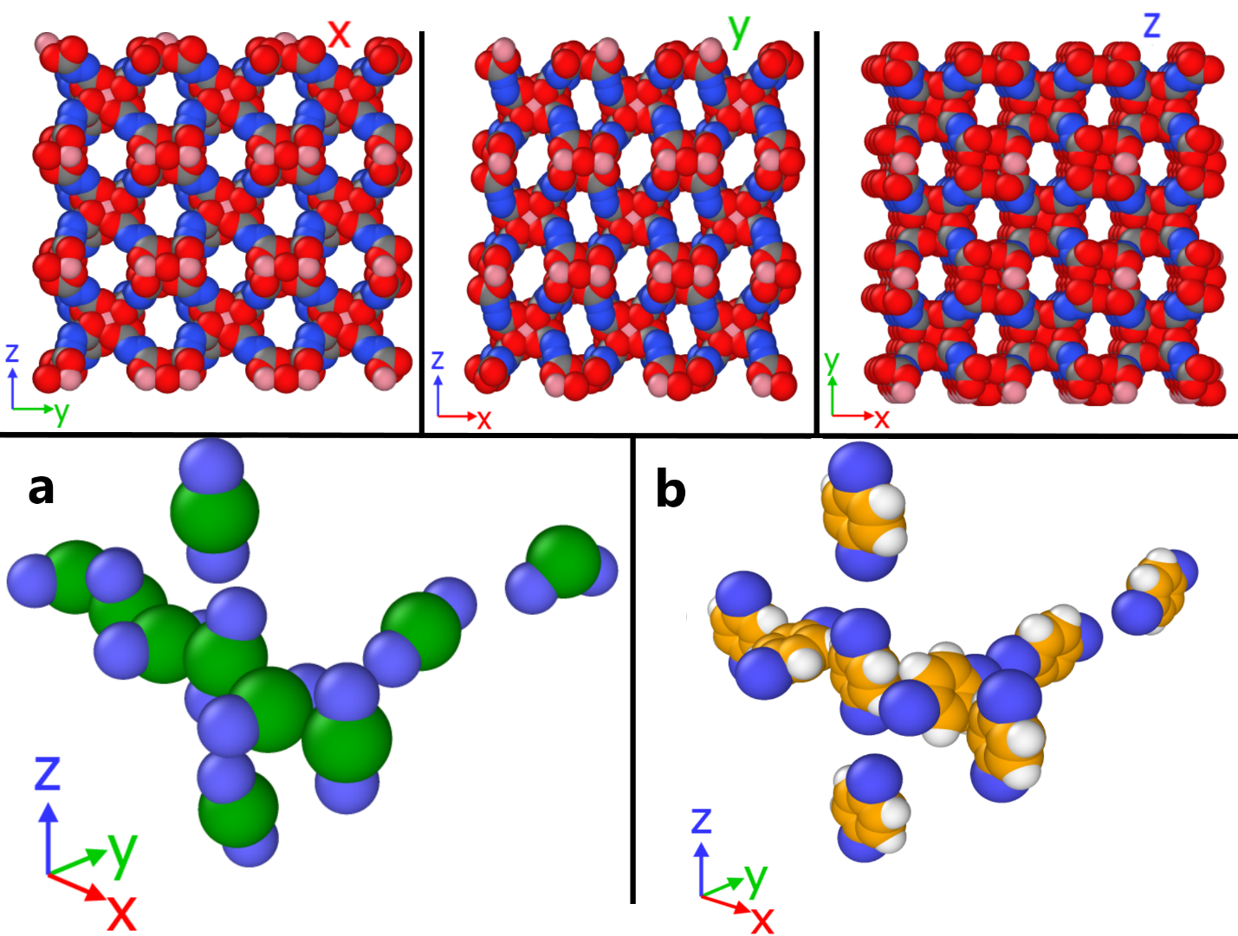

**Figure S9**. First row: MOF #199 from x (left), y (middle), and z (right) directions. Second row: snapshots of xylene mixtures in the interconnected channel of MOF #199. The averaged loadings of pX/oX/mX of the TSX model (left) is 2.51/0.19/0.03 with error bars of 0.039/0.025/0.032 mol/kg and of the full model using EB-CB/CFC is 2.27/0.29/0.15 with error bars of 0.018/0.028/0.021 mol/kg.

## MOF 8995

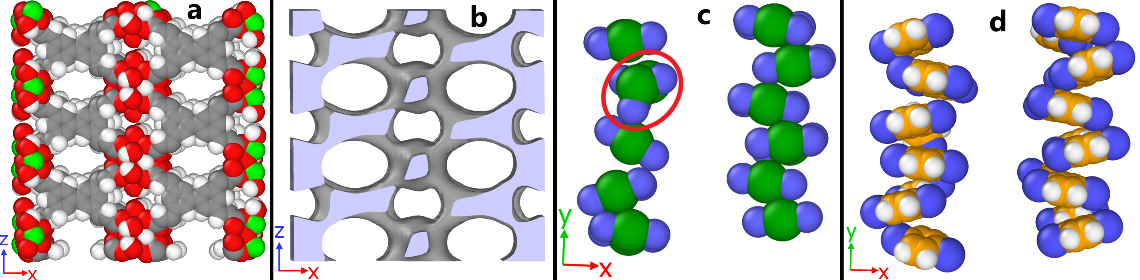

**Figure S10**. MOF #8995 (a), iso-surface (b), and packing of xylene isomers in 1D channels of MOF #8995 using the three-site model (c) and the full model (d). The individual loadings of pX/oX/mX for TSX and full model were 0.792/0.115/0.113 with error bars of 0.027/0.032/0.032 mol/kg and 1.016/0.043/0.022 with error bars of 0.105/0.028/0.032 mol/kg.

## MOF 9273

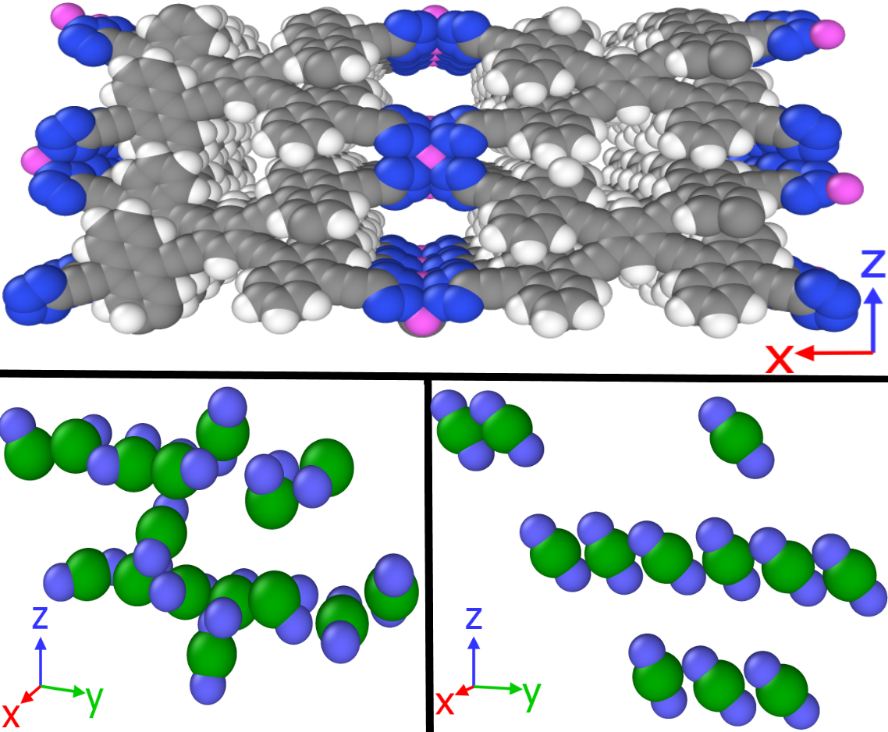

**Figure S11**. Framework and snapshots of xylene isomers in the two types of channels of #9273. The individual loadings for pX/oX/mX using TSX and full model are 1.160/0.289/0.300 with error bars of 0.024/0.003/0.008/ mol/kg and 0.978/0.527/0.440 with error bars of 0.095/0.092/0.063 mol/kg.

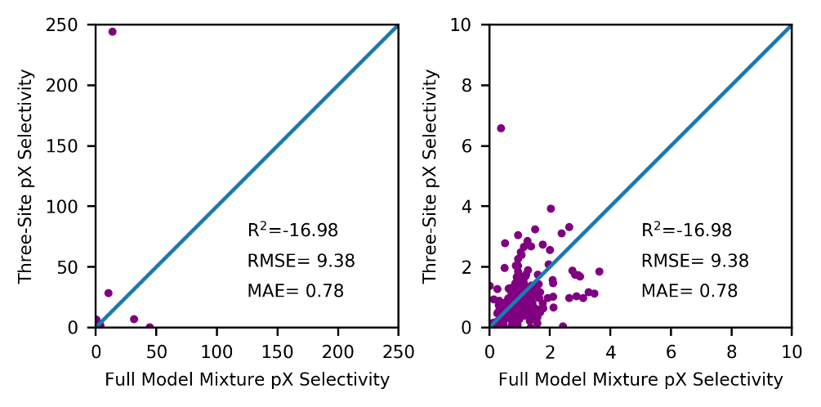

**Figure S12**. Comparison between TSX model selectivity versus full model selectivity. On the right we tried to zoom in to show the distribution of the selectvivities of the majority. R2 was calculated as $1-\frac{Σ_{i}{\left(y_{i}-{\hat{y}}_{i}\right)}^{2}}{Σ_{i}{\left(y_{i}-\overline{y}\right)}^{2}}$, where $y_{i}$ is full model selectivity, $\overline{y}$ is the mean of the full model selectivity, and ${\hat{y}}_{i}$ is the three-site model selectivity. A negative R2 means that there is no correlation between the selectivity from three-site model and the selectivity from the full model.

## MOF 4721

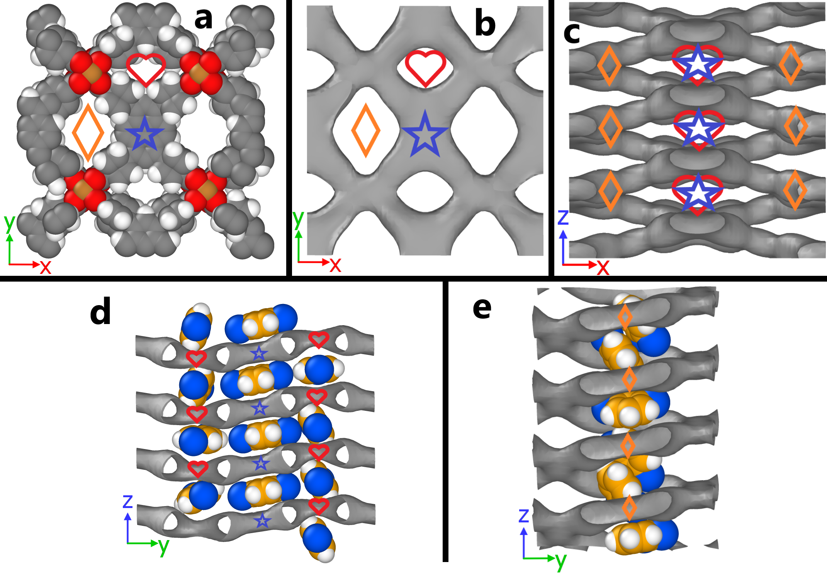

**Figure S13**. snapshots of MOF #4721. It is composed of parallel slits (blue star), small channel (red heart), and large channel (yellow diamond) from MOF #4721. Subfigure b and c display the isosurface of the structure in z and y directions. Subfigure d and e shows the adsorption snapshot of xylene mixture in small channel + slit and in big channel, respectively.



**Figure S14**. Site analysis of different regions within MOF #4721.

## Three-to-full workflow

During the simulations using the three-site models, RASPA writes restart files in the text format as snapshots that can be used as the starting point of another simulation. We then developed a python script that can convert three-site restart files into a full model snapshot that can be directly read by RASPA and start a simulation. For mX and oX molecules, the script will grow the carbon and hydrogen molecules of the aromatic ring on the plane determined by the methyl groups and the central approximate benzene site. For pX, the carbons and hydrogens will be grown with a randomly selected plane orientation. Then we take the newly generated position information will be written as a RASPA restart file and fed to the RASPA package. The python code is on Github (<https://github.com/snurr-group/Three-to-Full-Xylene>). Because randomly generated orientations will cause severe overlaps, GCMC simulation will delete the overlapping molecules to reduce the energies and destroy the packing patterns. Thus, we first equilibrate a system by running a simulation in a semi-grand canonical ensemble where only translation, rotation, reinsertion, and identity swap moves are performed. This will make sure that the system has reasonable energies so that the GCMC simulation later can retain the local structures without destroying them. A flowchart of the three-to-full workflow is given in Figure S15.

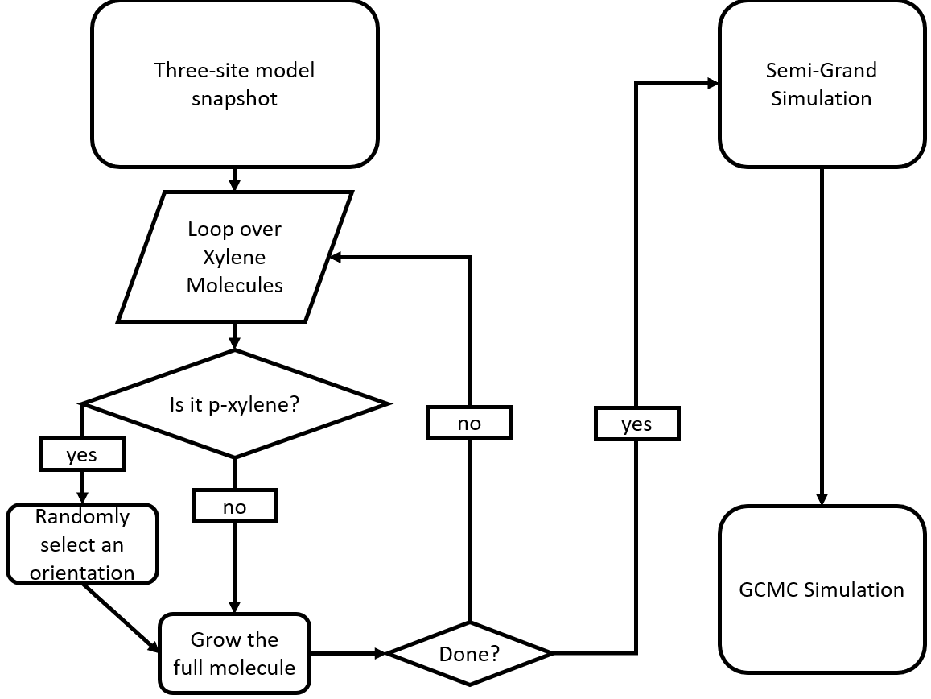

**Figure S15**. Flowchart of the process of a three-to-full workflow.

## MOF 100

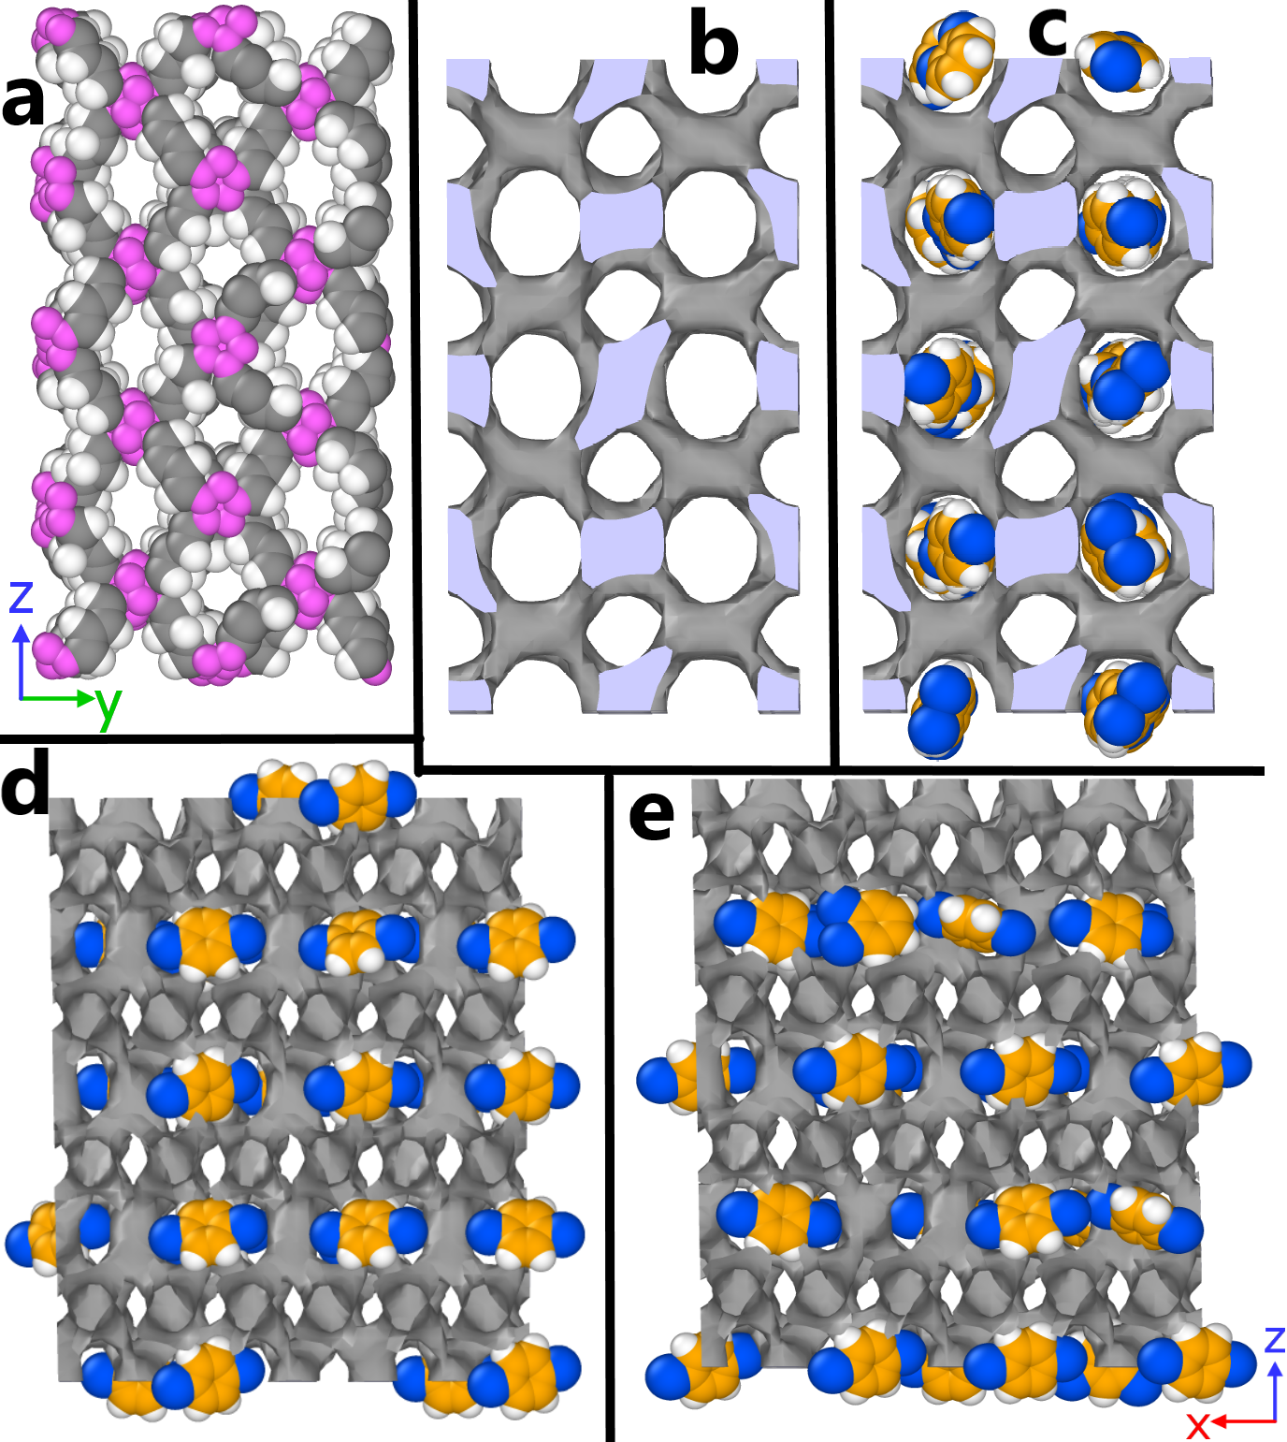

**Figure S16**. Snapshots and iso-surface for MOF #100. The pink atoms from (a) represent the nodes formed boron atoms. (b) and (c) represents the iso-surface of MOF #100, both without and with xylene adsorbed. (d) and (e) represents the sliced snapshot of the adsorbed xylenes for EB-CB/CFC simulation and CB/CFC simulation in the three-to-full workflow using 1,050,000 cycles. Subfigure a, b, and c share the same point of view while subfigure d and e have the same point of view.

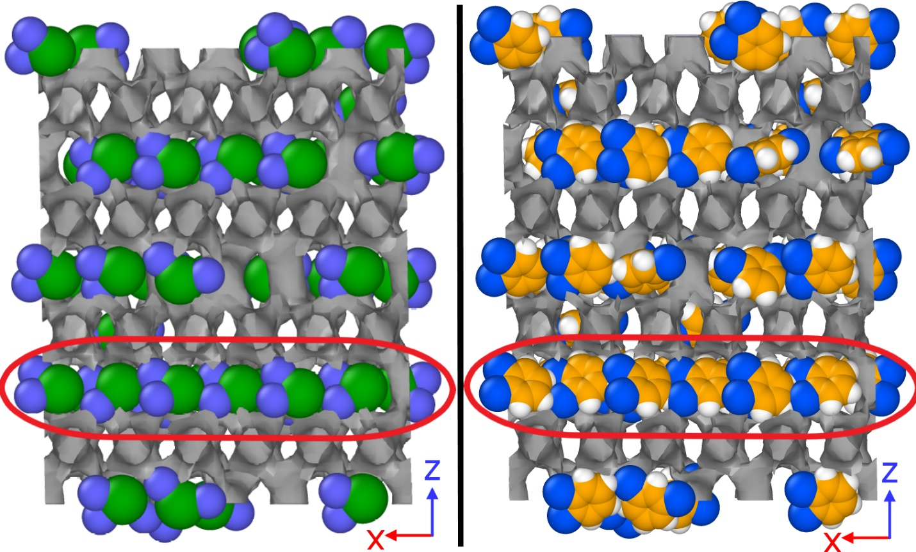

**Figure S17**. Left: Xylene isomer adsorption in MOF #100 modeled with the TSX model. We saw that oX molecules can stack up very efficiently in the highlighted channel. Right: snapshot of full model xylene isomer adsorption in MOF #100, printed at the first cycle of the semi-grand simulation. We see the highlighted channel has overlaps between methyl groups and hydrogen atoms of the oX molecules.

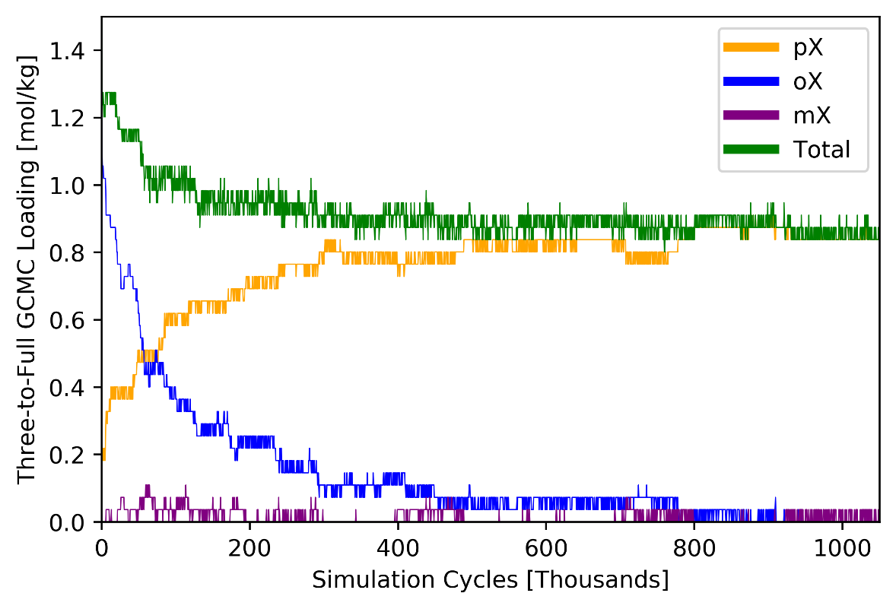

**Figure S18**. Cycle versus loadings for MOF #100 adsorption of equimolar xylene isomers at 433 K and 103 Bar fugacity using the three-to-full workflow.

## MOF 8925

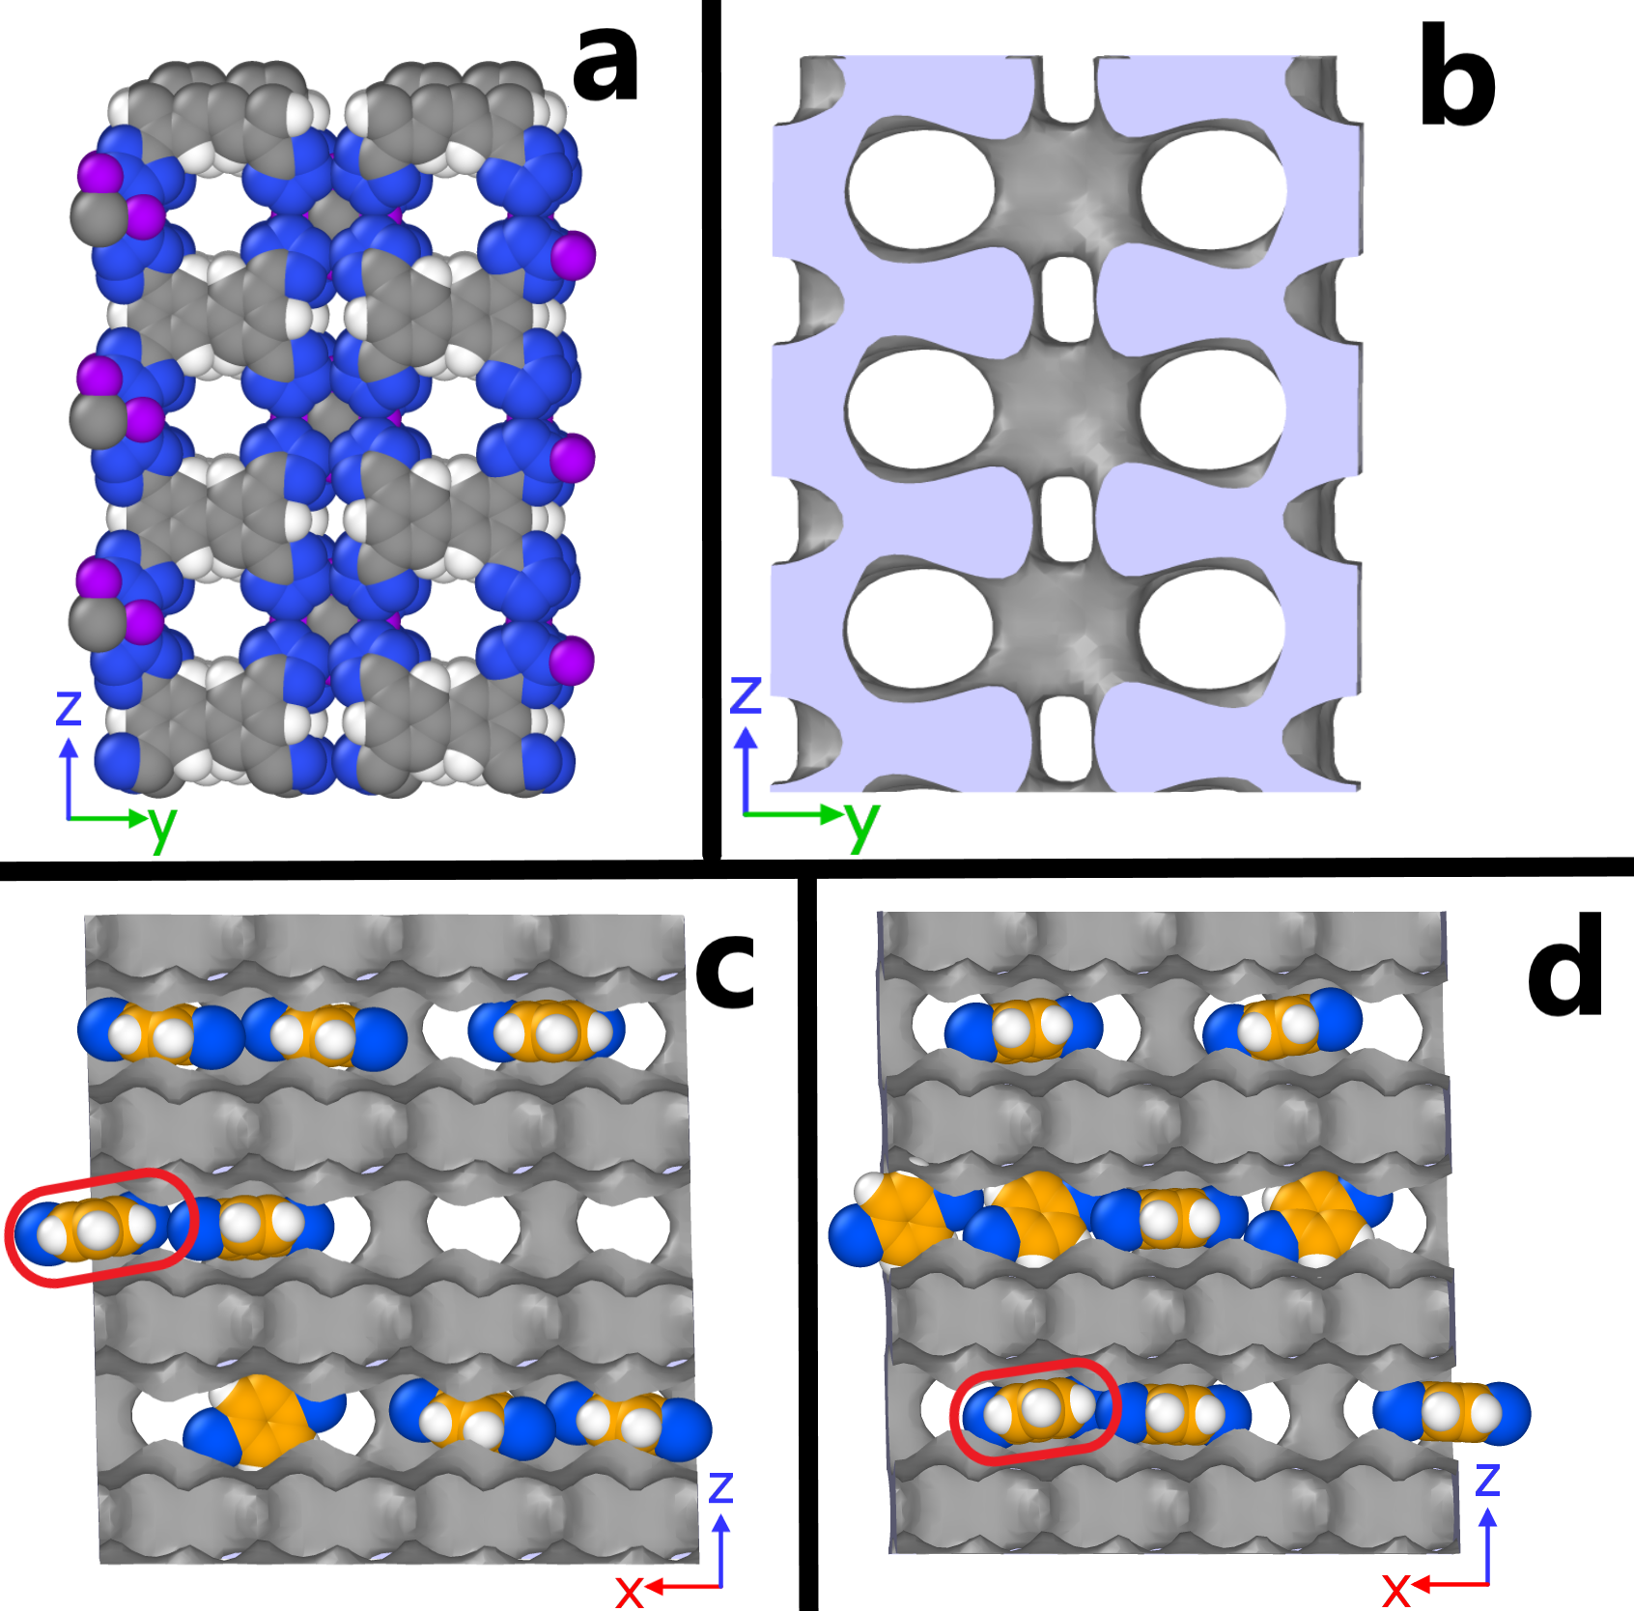

**Figure S19**. Structures and snapshots of MOF #8925. Subfigure a and b shows the empty structure and iso-surface of the MOF. Subfigure c and d shows the adsorption in the channels generated from EB-CB/CFC simulation and from the GCMC process of the three-to-full workflow. mX molecules in subfigure c and d were highlighted in red circles.

## MOF 8995

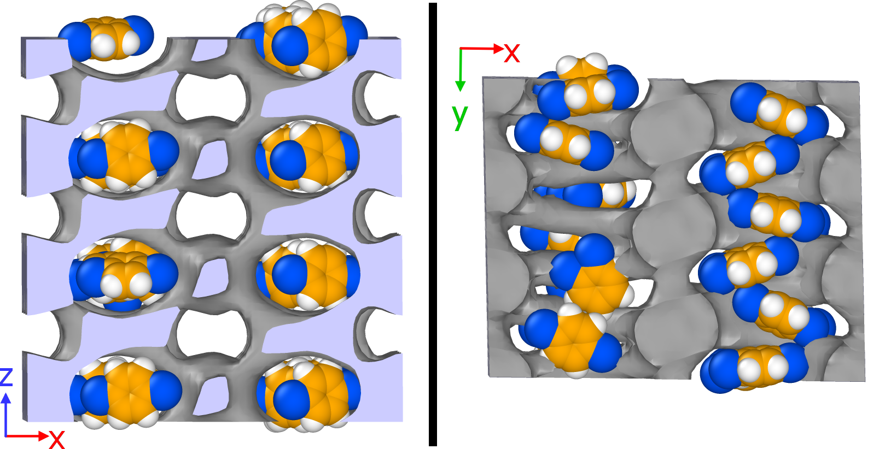

**Figure S20**. Xylene isomer adsorption in MOF #8995 snapshot during the semi-grand simulation. The left sub-figure shows the snapshot in the front and the right shows the snapshot from a top view.

## MOF 4908

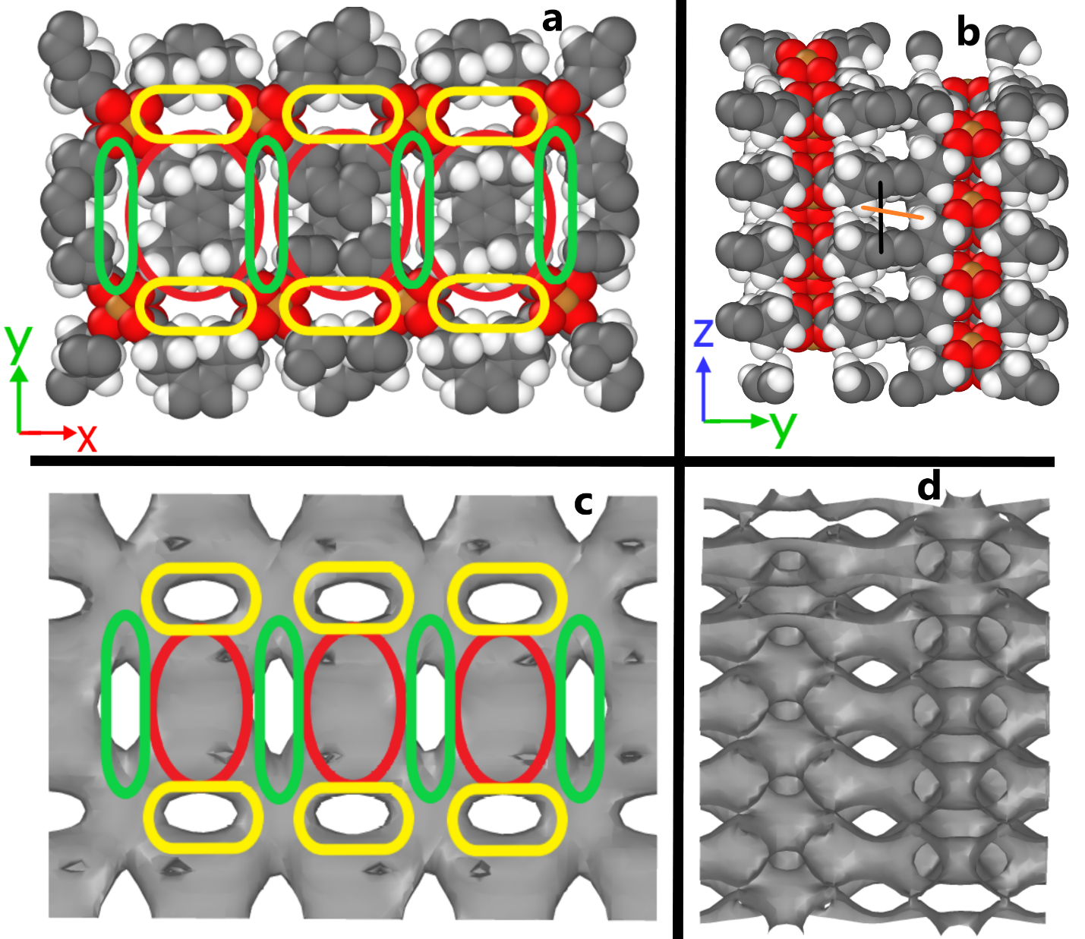

**Figure S21**. Empty structure of MOF #4908. a) The MOF has three types of slits/pores. b) From a side view, the structure is tilted a little and the areas of the red circled regions forms a “channel” visually. The black and orange lines represent the pore size vertically and horizontally. Subfigure c and d shows the iso-surface of the structure from the two views. Subfigure a and c are in the same view, and b and d are in the same view different from a and c.

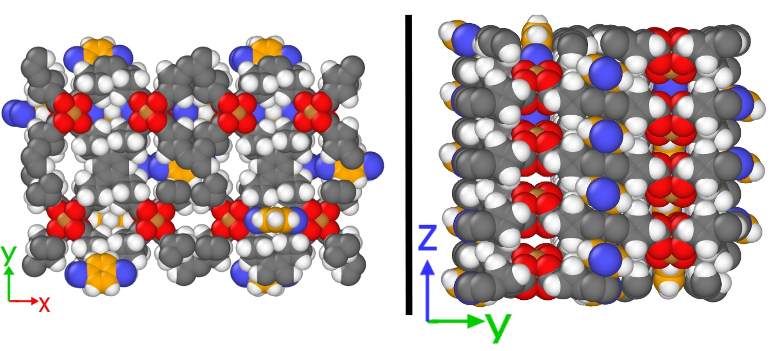

**Figure S22**. Equimolar xylene isomer mixture adsorbed in MOF #4908 simulated with CB/CFC.

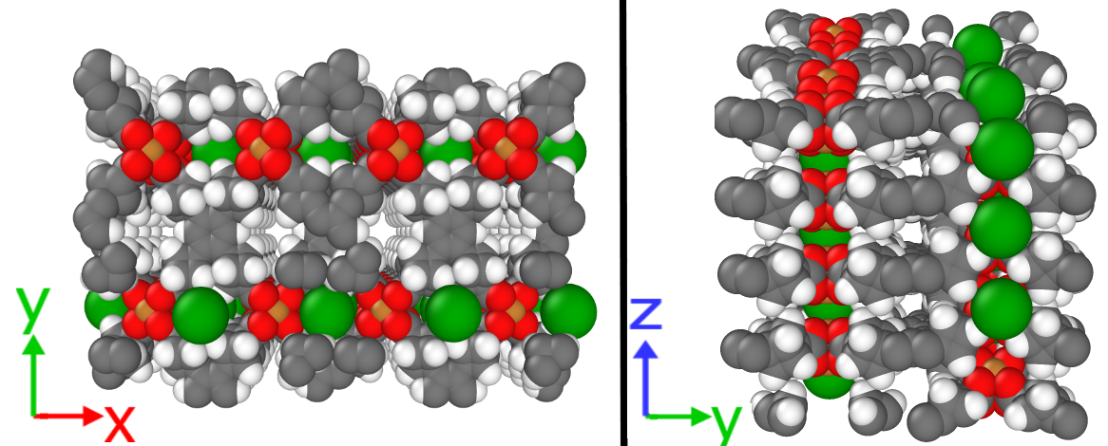

**Figure S23**. MOF #4908 with approximate benzene adsorbed.

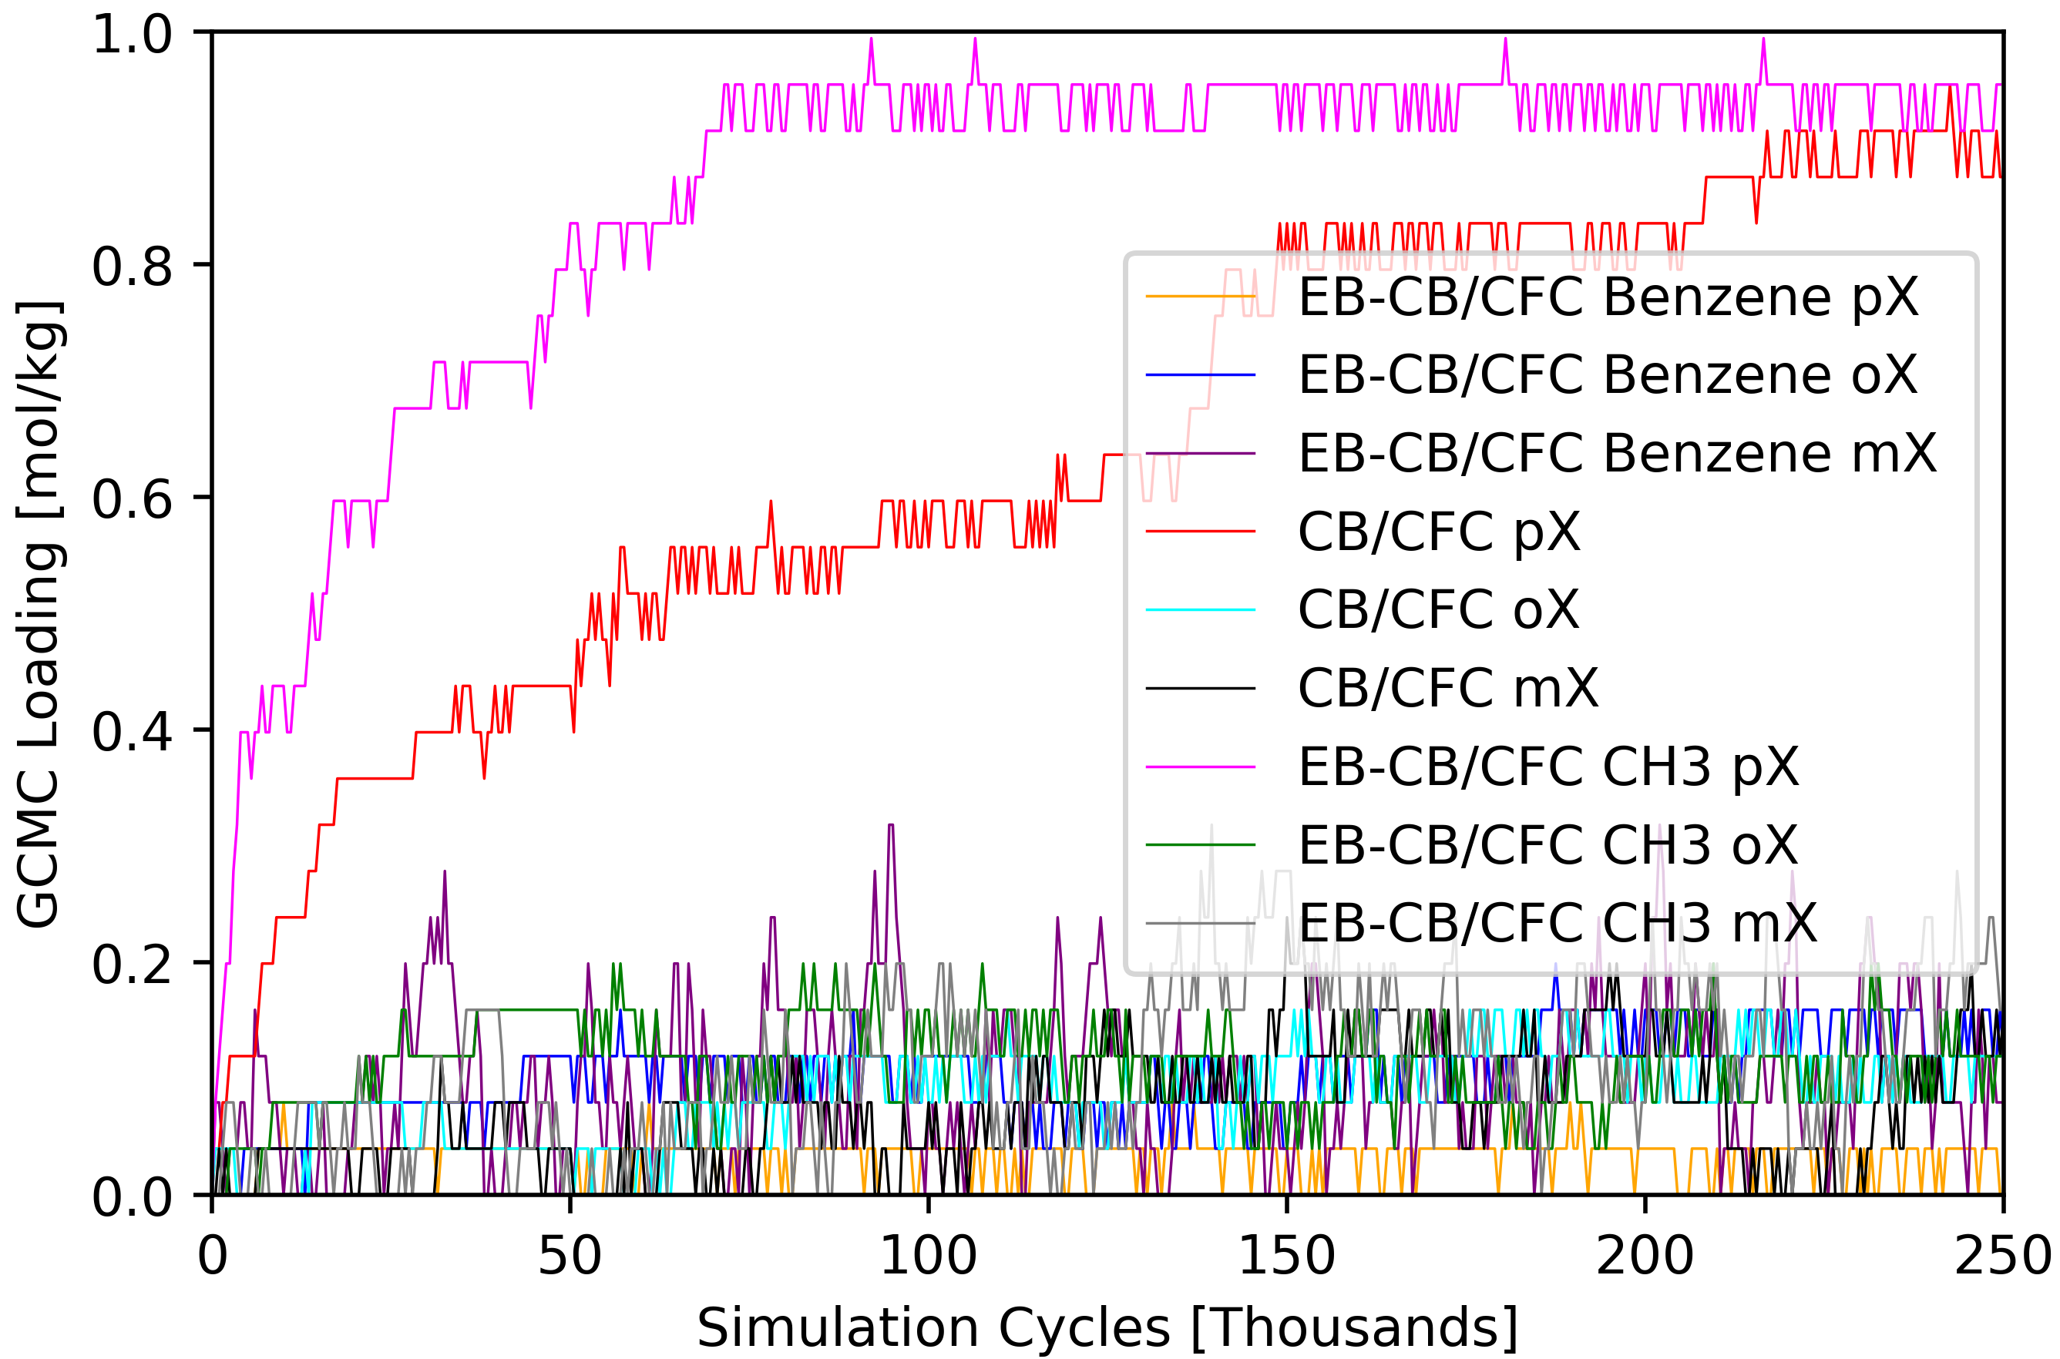

**Figure S24**. Comparison of cycle versus xylene isomer individual loadings for MOF #4908 using CB/CFC, and energy-biasing CB/CFC with an approximate benzene probe and effective methyl probe.

## Three-to-Full Workflow for MTW

We realized that when conducting the semi-grand simulation, because of the severe overlaps, RASPA generated a warning message saying that the semi-grand simulation is wrong because the energy calculated at the end of the simulation does not match the energy updated throughout the simulation. Because of this, we found that RASPA code caps energy calculations when there are severe overlaps. In normal scenarios, this cap helps with the speed of energy calculations because whenever the MC moves attempts unphysical moves that causes overlaps between atoms, RASPA will assign a huge positive energy and makes the move impossible to be accepted. However, this can cause issues for our case because the starting point has many overlaps because the cap yields incorrect energies at the start. Thus, for MTW, we removed the caps from the source code of RASPA. The new source code is available at <https://github.com/snurr-group/Three-to-Full-Xylene/tree/master/RASPA-without-capped-energies>.

## Three-to-Full Workflow for MOF MIL-47

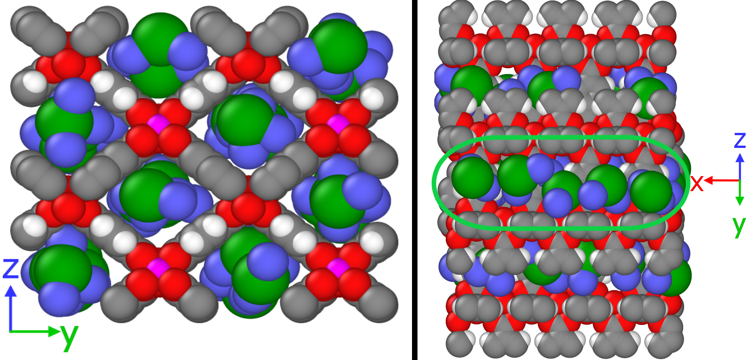

**Figure S25**. Three-site model of equimolar xylene isomers at 343 K and 4 kPa. A slice of a channel is highlighted on the right.

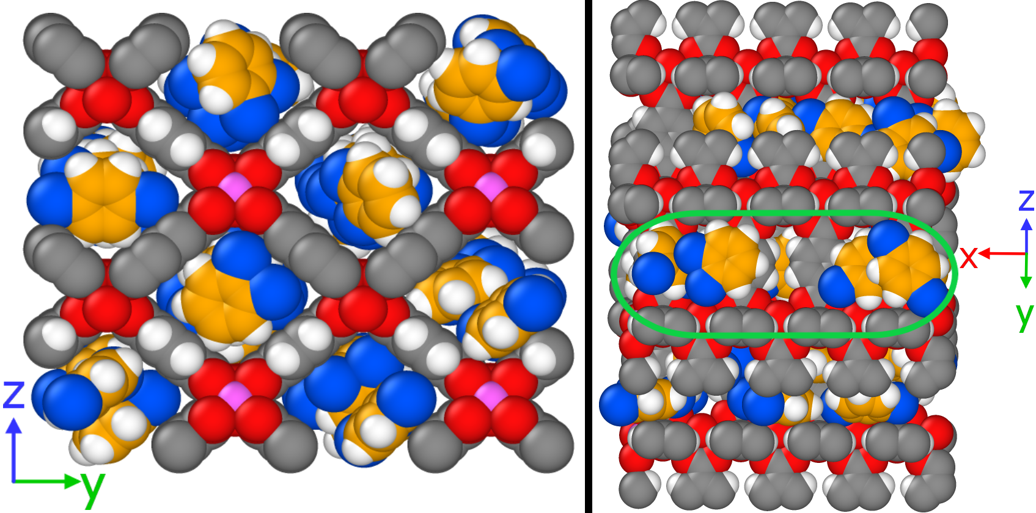

**Figure S26**. Full model snapshot after relaxation from the three-site model using semi-grand ensemble simulation at 343 K and 0.04 Bar. A slice of a channel is highlighted on the right.

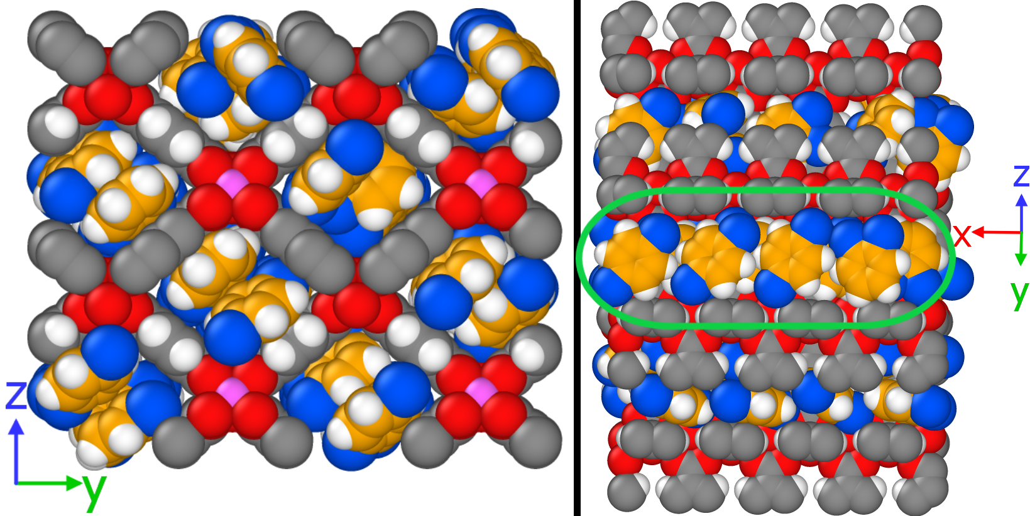

**Figure S27**. Full model snapshot after the GCMC using the final snapshot from the previous semi-grand relaxation. A slice of a channel is highlighted on the right.